125CC Dirt Bike Instruction

Open the box, get all spares out. See pic A.

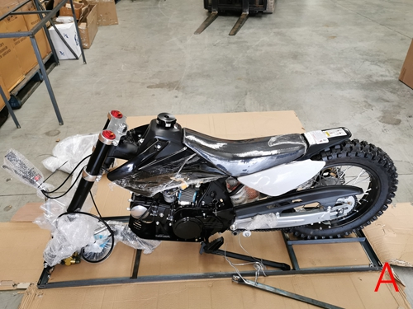

1, Install handlebar (4 bolts with brackets). See pic 1A,1B.

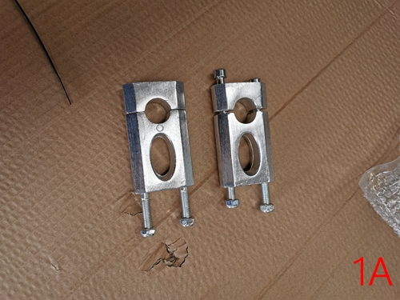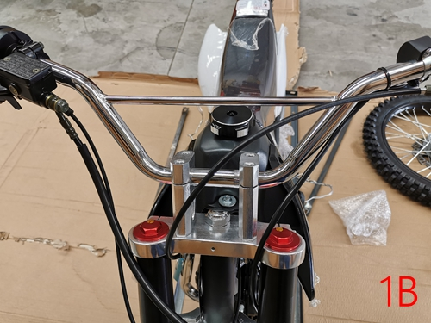

2, Remove the bolt/nut from the frame, put the bike on a bench. Pic 2A,2B.

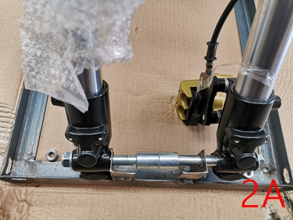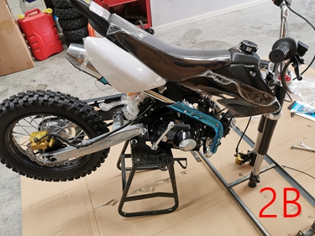

3, Install the rear shock. Only one bolt and one nut. See pic 3A,3B.

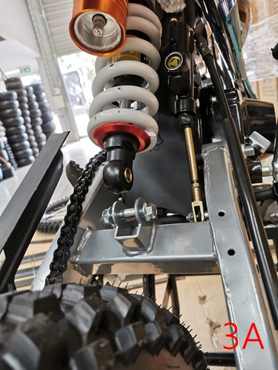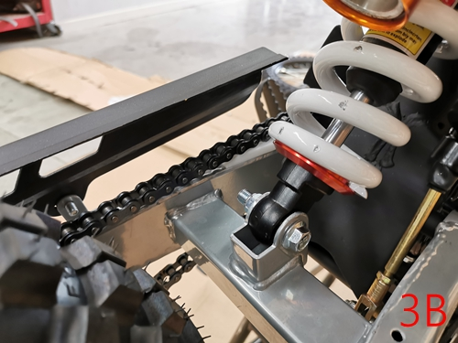

4, Install the front guards for front forks and fix the brake pipe. See pic 4A,4B,4C.

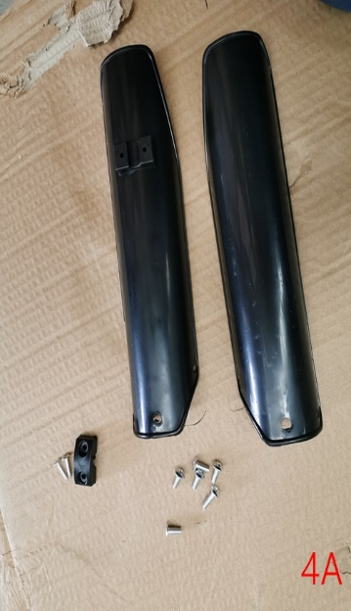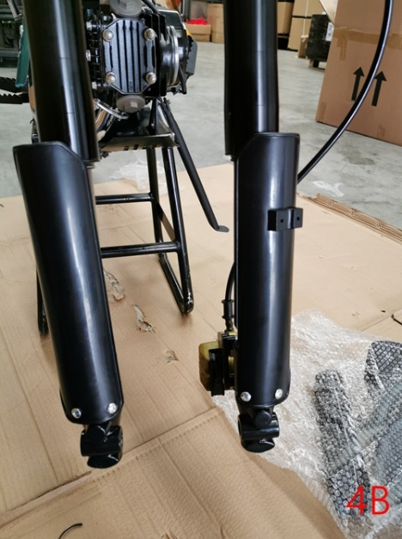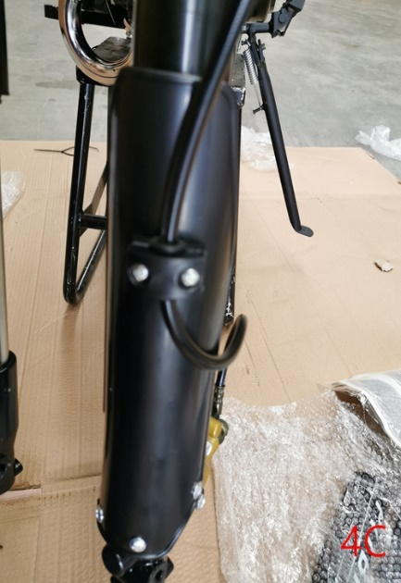

5, Install the front mudguard and number plate. See pic 5A, 5B, 5C, 5D.

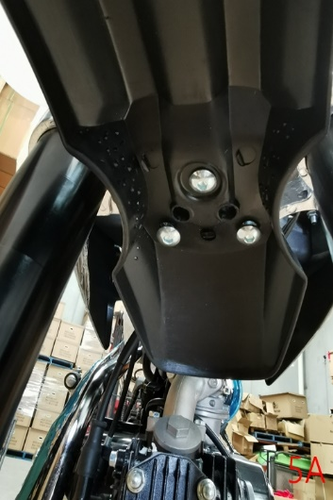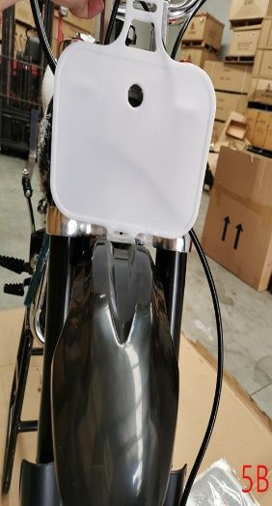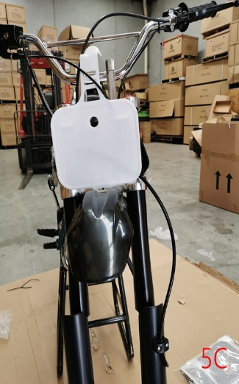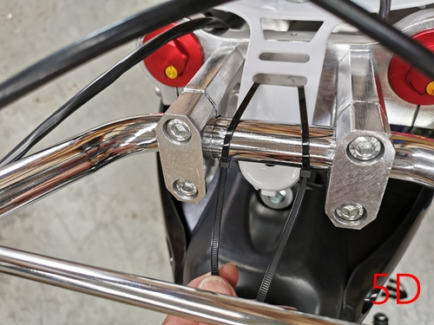

6, Install the front wheel. The longer spacer is located the disc side. The shorter spacer is on the other side. After tight the nuts, please spin the front wheel to check it. See pic

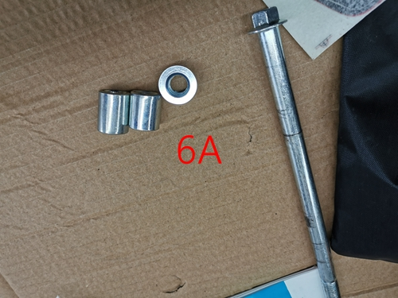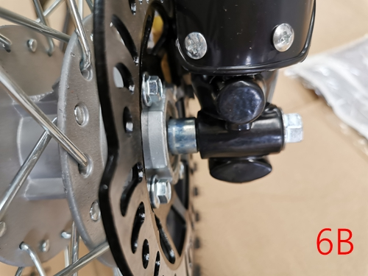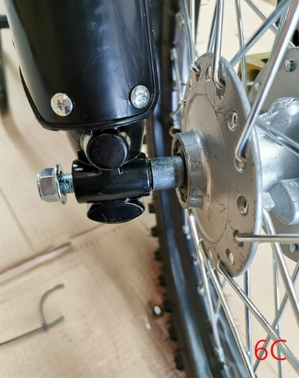

7, Install the gearshift lever. See pic 7A, 7B.

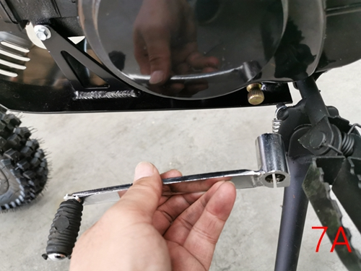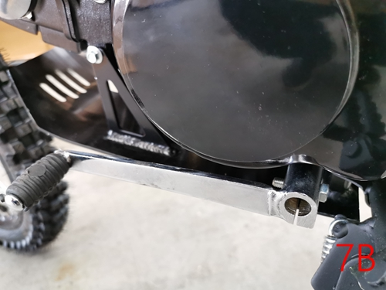

8. put the foam pad/chest protector on. See pic 8A, 8B.

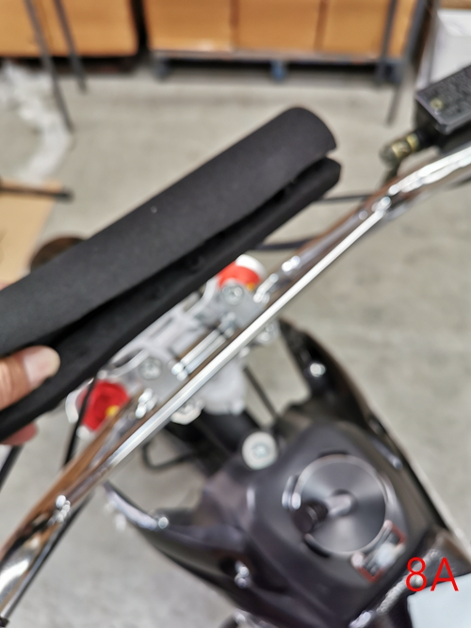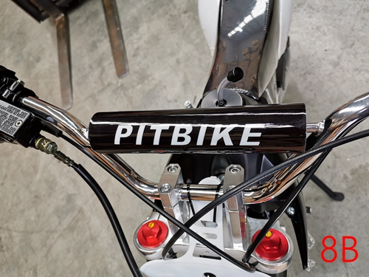

9, Assembly is finished. Stick stickers on the bike. See pic 9.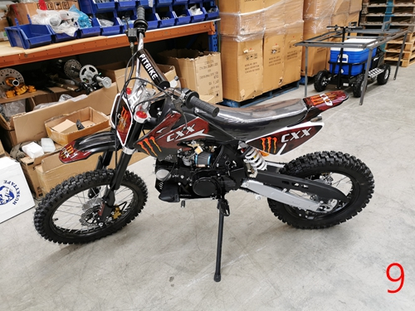

10. Fill petrol into the tank(unlead 91, no Octane or E10), check the engine oil level, turn on the fuel tap, key is on, kill switch is on. Then kick it to start.(please let choke on for cold day). Helmet/long sleeves/long pants/enclose shoes are required.